# 

# **Dunnhumby - The Complete Journey**

**Schema for the Dataset**

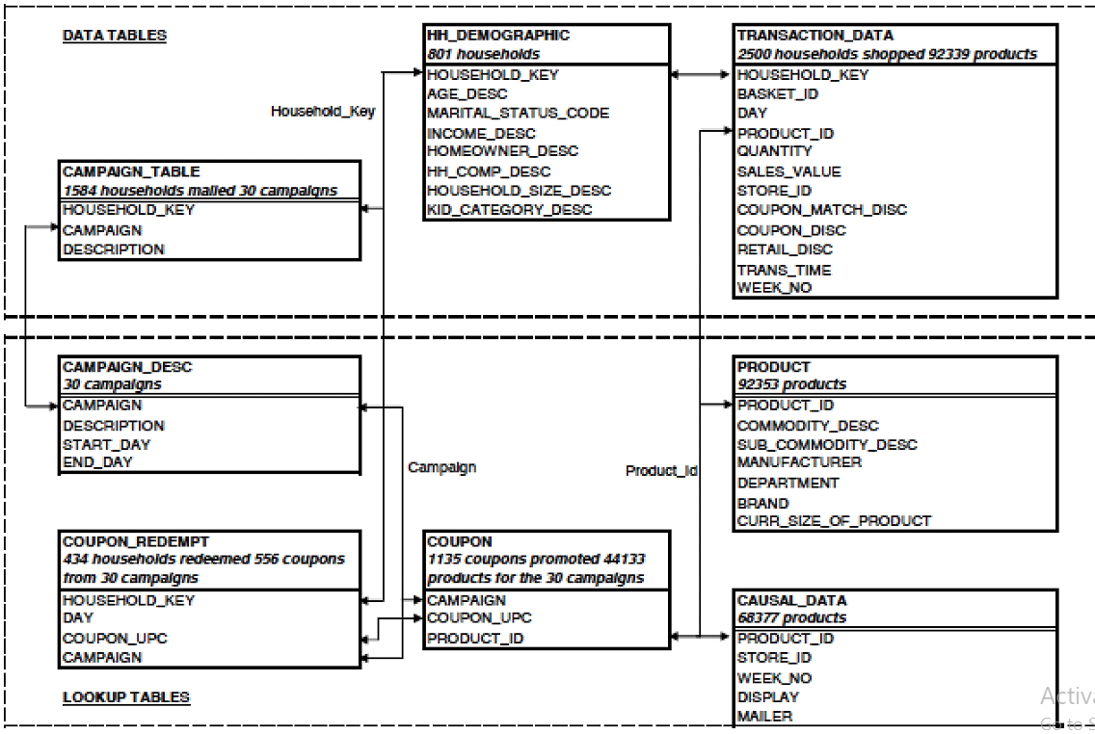

* **hh_demographic**

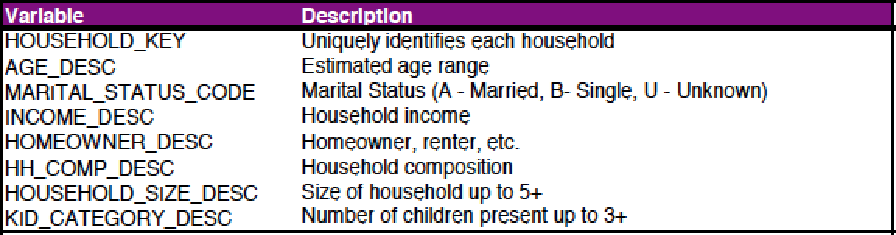

* **transaction_data**

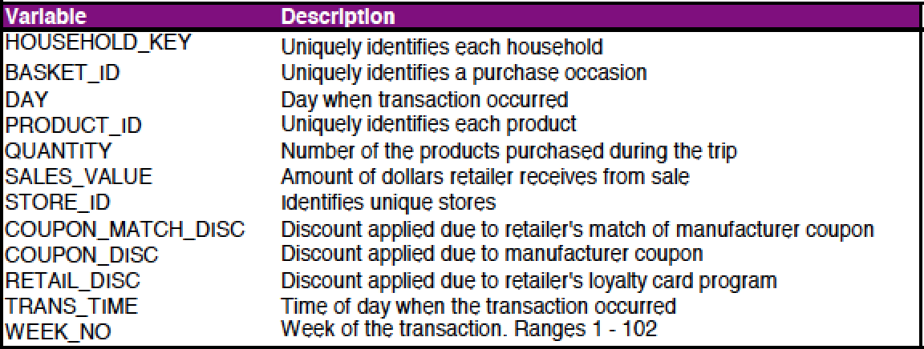

* **campaign_table**

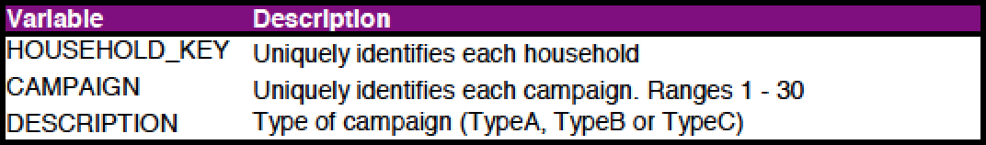

* **capaign_desc**

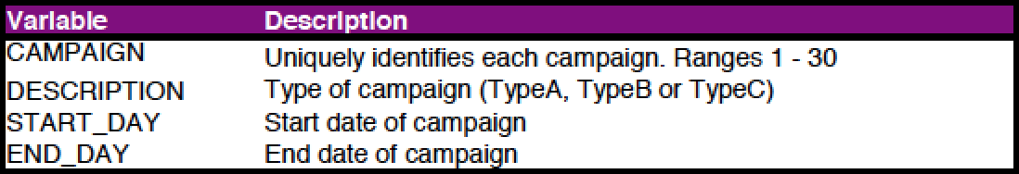

* **product**

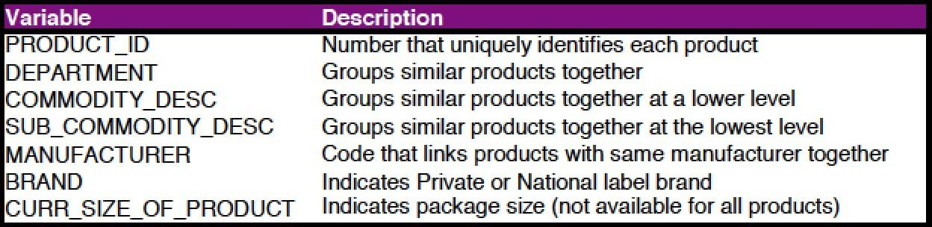

* **coupon**

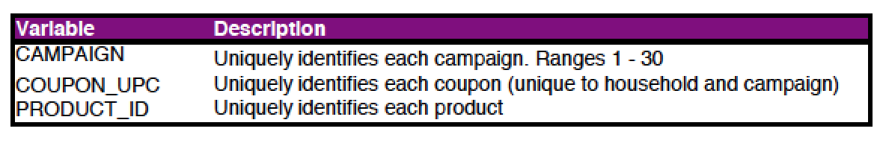

* **coupon_redempt**

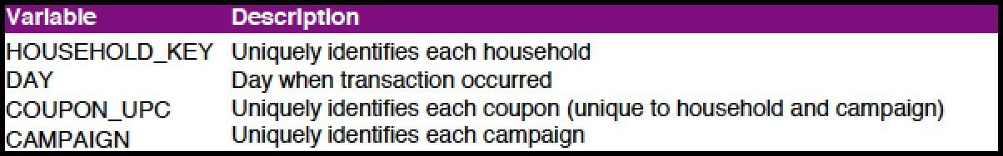

**Causal_data - event info and some other details**

